OFFICIAL COORDINATION REQUEST FOR
NON-ROUTINE OPERATIONS AND MAINTENANCE

COORDINATION TITLE- 16 LGS 13 Capacitive Coupling Potential Device (CCPD) Testing
COORDINATION DATE- July 6, 2016
PROJECT- Little Goose Lock and Dam
RESPONSE DATE- July 14, 2016

Description of the problem: The CCPD coupling should be tested every three years and has not been tested since 2002. Conducting the CCPD testing on 18 August aligns it with the T2 Doble testing already planned for August 15-19, minimizing system outage requirements. The CCPD inspections are required to validate line voltage to the GDAC system and not performing the tests puts the reliability at risk.

Type of outage required: During testing, units 1-6 will be out of service with unit 5 running at speed no load. The fish pumps will be out of service during switching operations, for approximately two hours in the morning and then again in the evening.

Impact on facility operation: Unit 5 will be operated at speed no load, while the other five units will be out of service. The fish pumps will be out of service during switching operations only.

Dates of impacts/repairs: August 18, 2016

Length of time for repairs: Testing is expected to take approximately 10 hours with the proposed time of 0700-1700. The fish pumps are anticipated to be out of service for about two hours in the morning and then again in the evening during switching operations.

Expected impacts on fish passage: This testing and the requirement to put units out of service will impact adult fish passage with lower flows in the adult channel. To minimalize impacts for returning adult salmonids this test will be done during the T1 and T2 planned outage. Fish pumps will be off during switch over only.

Fish Passage Historical Data

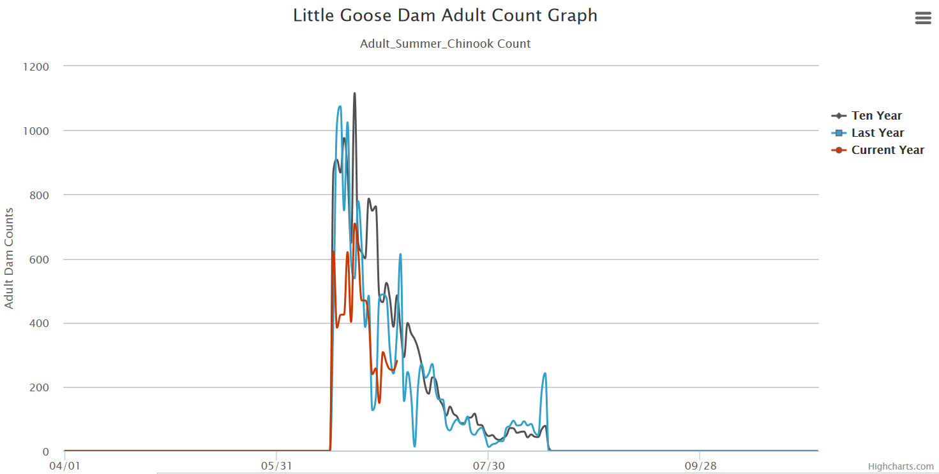

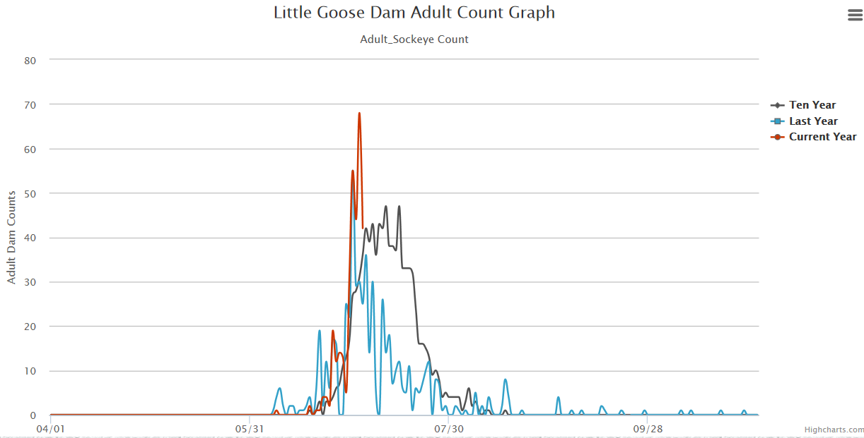

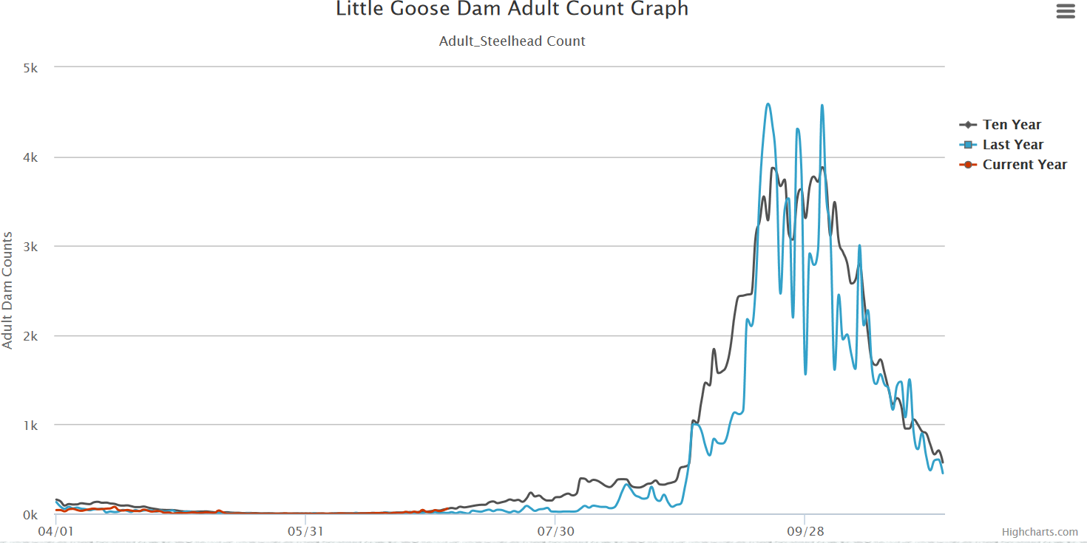

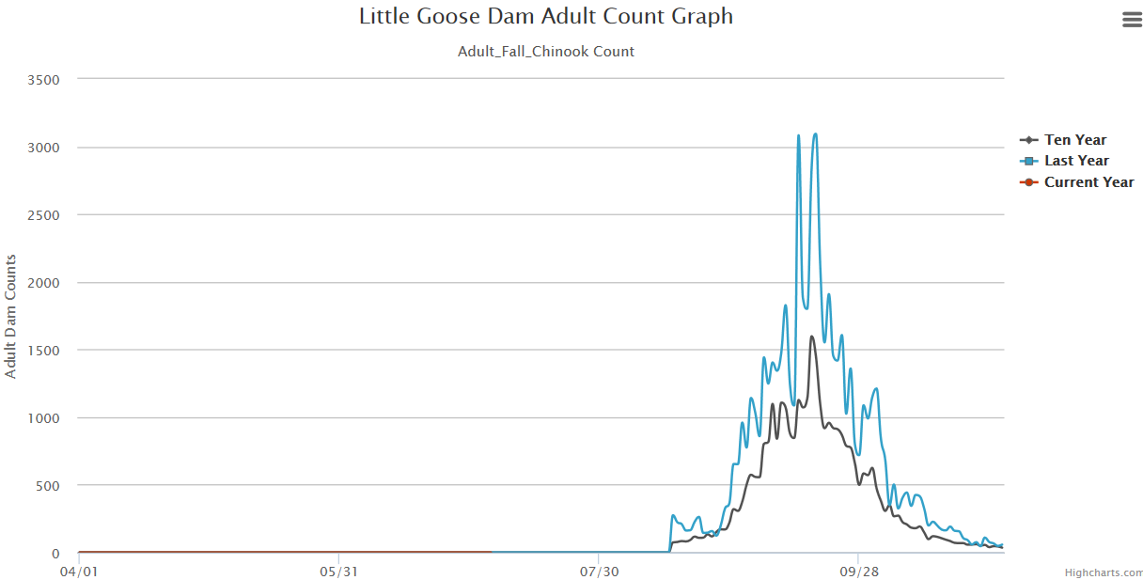

Comments from agencies

Final results

Please email or call with questions or concerns.
Thank you,

Richard Weis
Term Supervisory Fisheries Biologist, Little Goose Lock and Dam

